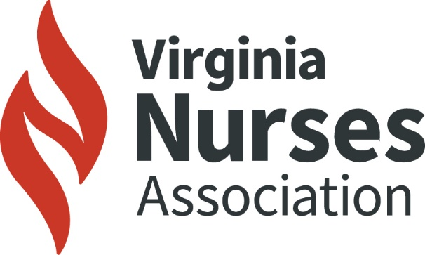
www.virginianurses.com
Certificate of Continuing Education
Awarded to

Elizabeth M. Wallace RN, MSN-Ed.

In Recognition of Participation in:
VNF/VNA Maternal Health Webinar Series: Pregnancy Loss
05-30-2025

Contact Hours Awarded: 1.75

The Virginia Nurses Association is accredited as a provider of nursing
continuing professional development by the American Nurses
Credentialing Center’s Commission on Accreditation.

